1. Multiply Strings (medium)

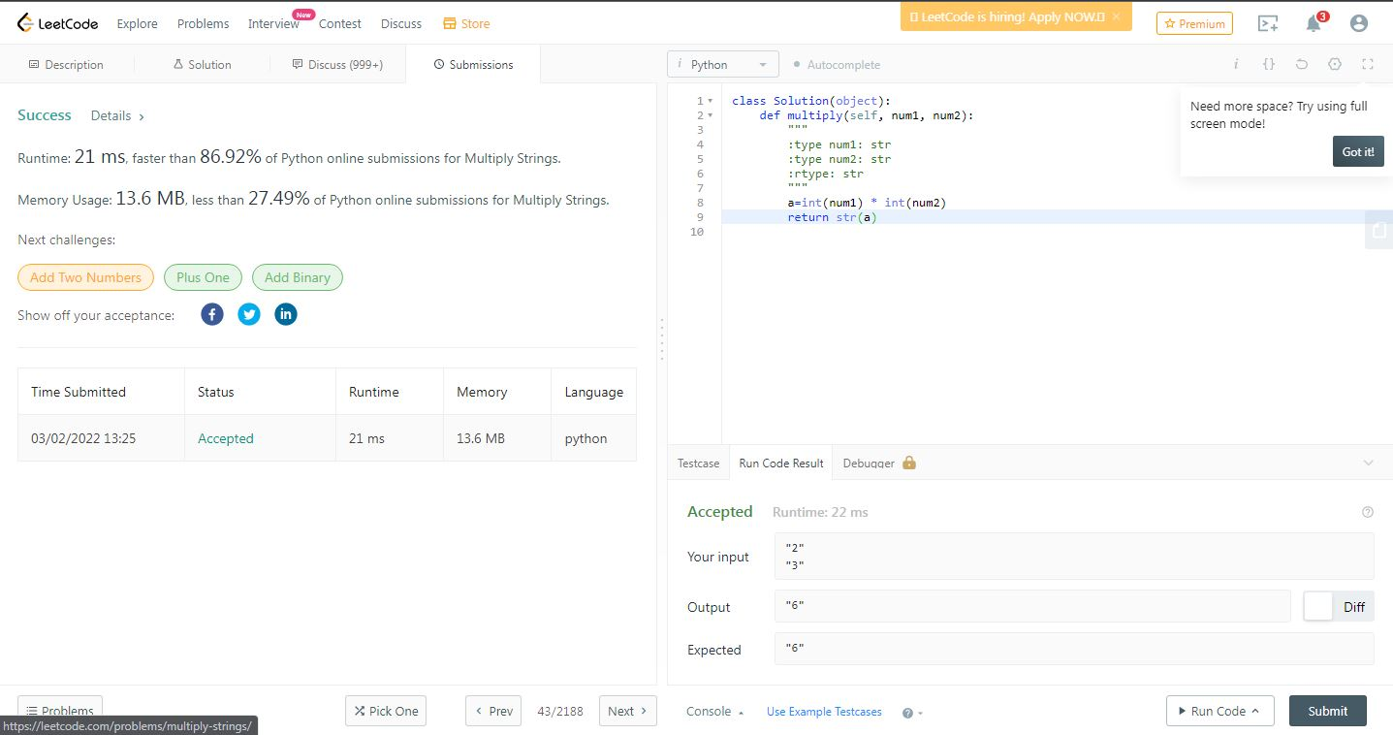

1. Reverse Words in a String (medium)

